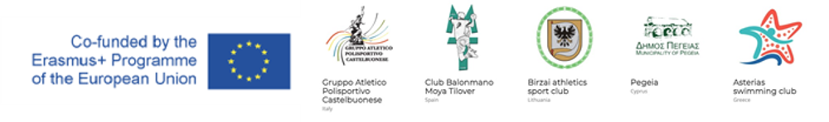
Project: MOVE – MOVing togEther
Project Number 613073-EPP-1-2019-1-IT-SPO-SSCP
Erasmus+ Sport – Small Collaborative Partnership
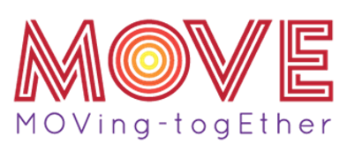
Toolkit
MOVE Project
Contents of the Toolkit
1. Introduction..............................................................................................................................................2
2. Aims and Objectives of MOVE Project.................................................................................................2
3. Reflection on focus themes of MOVE project.....................................................................................3
4. The analysis in each country involved in the partnership................................................................3
4.1. Italy.........................................................................................................................................................3
4.2. Lithuania................................................................................................................................................4
4.3. Greece ....................................................................................................................................................6
4.4. Spain.......................................................................................................................................................8
4.5. Cyprus.....................................................................................................................................................10
5. The Peer Transnational Meeting (M2) ................................................................................................10
6. Activities proposed to stimulate the reflection of young people on the focus themes of MOVE
Project ...............................................................................................................................................................11
7. Activities proposed to use the language and methodologies of sport activities as educational
tool and instrument of social inclusion and respect for different people...........................................14
8. Activities proposed to measure the level of satisfaction of young people during the local
activities.........................................................................................................................................................21
1. Introduction
The Toolkit is a document of the Project "MOVE - moving together" which aims to raise awareness among the various age groups (especially children and adolescents) and their educators on the ability of Sport to oppose and combat intolerance and discrimination, promoting social inclusion, equal opportunities, as well as offering important benefits for physical and psychological health. It involves the following partners:
- A.S.D. Associazione Sportiva Dilettantisca Gruppo Atletico Polisportivo Castelbuonese (ITALY), the project coordinator;
- BLASK - Birzu lengvosios atletikos sporto klubas (LITHUANIA)
- ASTERIAS - KOLYMVITIKOS ATHLITIKOS OMILOS ASTERIAS (GREECE)
- Club Balonmano Moya Tilover (SPAIN)
- Municipality of Pegeia (CYPRUS)
2. Aims and Objectives of MOVE Project
The objectives of this project are as follows:
- Promote and reinforce the partners’ ability to operate in a network on a European dimension, sharing ideas, methods, techniques and best practices in order to promote the education by and through sport, support socio-cultural inclusion pathways and improve their levels of performance;
- Promote and reinforce the vision of sport as educational tool and as a method to promote social inclusion and equal opportunities and raise awareness of its potential to combat and prevent among young people phenomena of discrimination, intolerance, racism, violence and bullying;
- Promote the mobility of instructors / coaches / educators / sports animators, staff of non-profit organizations in order to strengthen their path of training and specialization and transferring them skills and abilities to use sport as educational instrument, functional to the creation of an open, inclusive and respectful community of other cultures, thus helping to support:
A) local paths of socio-cultural inclusion among children, adolescents, young people and adults;
B) local paths of equal opportunities between men and women in sport;
C) higher participation in the sports activities of children, adolescents, young people and adults.
- Transfer to children and adolescents, and their educators, coaches, instructors, through sport, a full awareness about the issues of socio-cultural inclusion and respect of different people, thus removing prejudices and feelings of fear or in extreme cases of hate, which can potentially turn into episodes of violence, racism, intolerance and bullying;
- Raise awareness of children and adolescents, and their educators, coaches and instructors, regarding the importance to practice sport and physical activity in order to limit and prevent psycho-physical damages caused by excessive sedentary lifestyle and technological alienation and isolation, since nowadays young people are totally immersed in the digital dimension and they are much more inactive physically;
- Encourage children and adolescents, and their educators, coaches, instructors, to practice sports and physical activity, also outdoors or immersed in nature, in order to enjoy the physical and mental benefits related to: improving mood, increasing energy, decreased levels of stress, anxiety and anger, more sensitivity to respect the environment;

- Promote and strengthen more participation in local sports activities of children and adolescents, also in contact with local population and disadvantaged groups as ethnic minorities, immigrants, disabled people, etc

3. Reflection on focus themes of MOVE project
The themes addressed in the Project are the risks of technological isolation, linked to the excessive use of digital applications, and the progressive diffusion of diseases, such as childhood obesity linked to excessive sedentary. The excessive use of technological devices represents a serious threat to social inclusion, especially for the growth of children and adolescents who become increasingly sedentary. Factors such as sedentary lifestyle therefore pose a risk to health, especially for the development of cardiovascular diseases. Sport is one of the best tools to prevent the above-mentioned risk factors and to help combat social discrimination.
4. The analysis in each country involved in the partnership
Each partner of the project has developed a statistical analysis of their country
4.1. Italy
- Brief analysis and reflection on the negative effects of excessive sedentary lifestyle, for example the progressive spread of childhood obesity and overweight, low levels of physical activity of children, adolescents and young people, and on the importance of promoting and strengthening the participation of young people in physical activity (also immersed in nature) to limit the negative effects on their psycho-physical wellness.

ITALY
According to the Italian Ministry of Health, 36% of Italian children and adolescents are obese, and compared to 1990 sedentary life has increased by 39.1%. The many scientific researches conducted on the Italian territory report how sedentary behavior adversely affects about psycho-physical health:
- Weakness, fatigue and muscle and joint pain (such as back pain);
- Increases the risk of developing cardiovascular diseases and relate problems such as diabetes and obesity;
- Reduces the efficiency of the immune system;
- Negatively affects socialization;

One of the main causes of Italian youth sedentary lifestyle is the excessive use of technological devices
- https://www.clinicasanmartino.it/blog/gli-effetti-della-sedentarieta-sul-nostro-corpo/#:~:text=Gli%20effetti%20della%20sedentariet%C3%A0%20sul%20nostro%20corpo%201,parlato%20in%20un%20precedente%20articolo.%20Pi%C3%B9%20articoli...%20;
- https://ilfaro24.it/vita-sedentaria-quali-sono-gli-effetti-sul-nostro-organismo/#:~:text=Dati%20recenti%20mostrano%20che%20oltre%20la%20met%C3%A0%20della,una%20percentuale%20oscilla%20tra%20il%2060%20e%20l%E2%80%9980%25.

- Brief analysis and reflection on the issue and risk of technological isolation of young people, due to the excessive use of digital tools and applications.

ITALY

According to some Italian statistics, 41% of Italian children use a technological device for at least two hours a day. In particular:
- 38% italian children under 2 years old have already used a mobile device to play games or watch a video;
- 63% of italian children up to the age of 8 use their parents' devices; while those from the age of 8 are the 70%;

This phenomenon has caused a high physical inactivity of children and adolescents, who prefer to spend time at home instead of practicing physical activity and sports. Infact the 36% of italian childrens and adolescents don’t practice physical activit. All this entails risks for psycho-physical health (obesity, sedentary lifestyle, lack of social relations...).

To face these problems, Italy should promote sport more, especially in schools or take example from some foreign actions: for example in Romania you do not pay public transport tickets if you do 20 squats before entering.
Other solutions could be to replace the use of the machine with the use of the bike, or even walking or organizing some excursions in the municipal landscapes to enhance their environments and territories.
- https://www.epicentro.iss.it/attivita_fisica/bambini-Adolescenti#:~:text=Rispetto%20a%20comportamenti%20che%20favoriscono%20la%20sedentariet%C3%A0%2C%20dai,figli%20con%20genitori%20con%20basso%20titolo%20di%20studio
- https://massimilianopiroli.com/lattivita-fisica-e-in-calo-quali-soluzioni-adottare/
- https://www.nostrofiglio.it/bambino/bambini-e-tecnologia

4.2. Lithuania
- Brief analysis and reflection on the negative effects of excessive sedentary lifestyle, for example the progressive spread of childhood obesity and overweight, low levels of physical activity of children, adolescents and young people, and on the importance of promoting and strengthening the participation of young people in physical activity (also immersed in nature) to limit the negative effects on their psycho-physical wellness.

LITHUANIA
In 2011, Department of Youth under the Ministry of social care and labor of the Republic of Lithuania ordered special professional sociological research to identify the problem young people encounter with in their everyday life. 404 respondents took part in this research. Research showed that 50 % of students are in a stable normal psychological condition. 38 % have encountered sadness, insomnia, excruciating anxiety. 12 %are in a bad psychological condition. 60 % of respondents have middle self-esteem, 36 %t – high and 4 % – low.
In 2015 Vilnius University made research on the BMI of its students:
• Normal weight students – 78,5 perc.
• Overweighted – 9,3 perc. More male students were overweighted – 19 perc. for female students this rate was – 4,5 perc.
• Too little weight – 11,4 perc. More female students felled to this category – 16,2 perc. while male – 1,7 perc.

In 2017, 274 227 students (7-17 years old) were attending schools in Lithuania. In Lithuania it is obligatory to make prophylactic health observation of every child before the school year starts, however, 9,2 perc. (25 222) of students had no records about their body mass index (BMI). From those who’s BMI were evaluated (249 005), 67,5 perc. had normal weight, 15,41 perc. had overweight, 6,18 perc. – obese. In Lithuania only 40,5 perc of inhabitants reach the physical activity level proposed by WHO. 51 perc. of Lithuanians have never done sport. It is higher than average of EU (46 perc.). In Biržai 21,6 perc. of students at the age 7-17 have problems with overweigh and obesity, physical activity level is lower than average (Children health, 2017, Institute of Hygiene, Lithuania).
It is obvious that good mental and body health are closely related. Weight and the way person perceive his body can have a negative effect on the overall psychological well-being of a child or adolescent status. These include: depression, heavy weight bullying, partial social isolation and discrimination. And this negatively affects the self-esteem of an obese child.
Through there are a lot of information about the energetical value of the food, people still do not understand it or have their own vision about it. It is very important to explain the real meaning of the numbers and codes on Food packages. To tackle the problem of overweight of young people, we need to meet them directly and talk about the food, calories, energy, necessity of being active in funny, understandable way with clear examples. Broshures, lessons and info on TV will not help – we need to talk to young people face to face and provide examples.
European Commission states there are indications that cooperation among different organizations and sport have a positive impact on acceptance of diversity in community and development of prosocial skills, leadership, decision-making skills and self-esteem of learners (EC, 2014c).

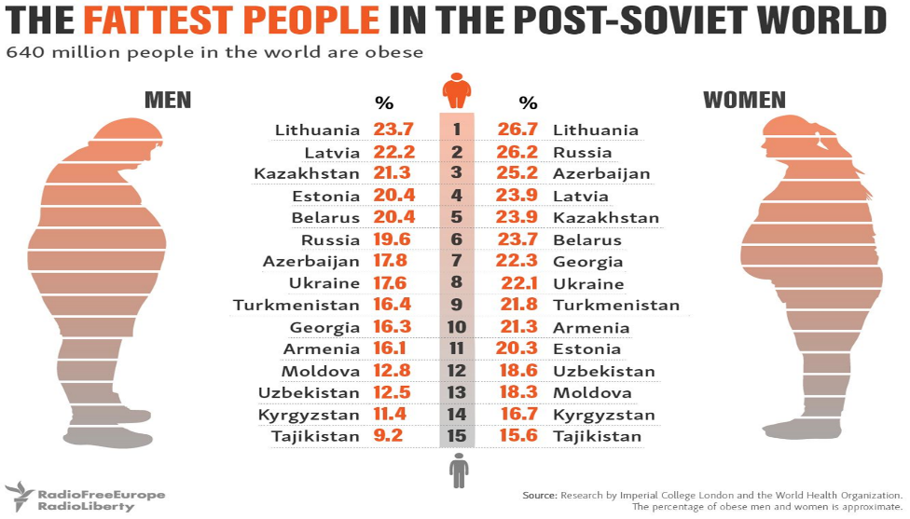

https://osp.stat.gov.lt/lietuvos-gyventoju-sveikata-2020/kmi
http://www.smlpc.lt/media/file/Skyriu_info/Mityba_ir_fizinis_aktyvumas/Mityba/Antsvorio_ir_nutukimo_paplitimas.pdf
https://www.hi.lt/news/1684/1246/Pristatomi-mokiniu-KMI-ivertinimo-ir-dantu-bei-zandikauliu-bukles-duomenys.html
https://sam.lrv.lt/fizinio-aktyvumo-situacija

- Brief analysis and reflection on the issue and risk of technological isolation of young people, due to the excessive use of digital tools and applications.

LITHUANIA
In 2017 the highest rates of daily computer use among young people were recorded in Czechia (90 %), Poland, Slovakia (both 89 %) and Lithuania (88 %). By contrast, the lowest proportions of young people making daily use of a computer were recorded in France (68 %), Italy (66 %) and Spain (61 %).
Croatia, Poland, Greece, Lithuania and Romania all recorded rates for the daily use of computers among young people that were more than 25 percentage points above the rates for the whole of their adult populations in 2017.
Data on the use of mobile devices to connect to the internet when away from home or work in 2019 shows that these were used by more than 9 out of 10 young people aged 16-29 years in the vast majority of EU Member States.
The study to evaluate the prevalence of Internet addiction among 13–18-year-old schoolchildren and its relation to sex, age, and time spent playing computer games, game type, and subjective health evaluation was performed in Lithuania in 2016. A total of 1806 schoolchildren aged 13–18 years were interviewed. The evaluation of Internet addiction was conducted by the Diagnostic Questionnaire according to Young's methodology. The relation between the choice of computer games type, time spent while playing computer games and respondents’ Internet addiction were assessed by using multivariate logistic regression analysis. Results:
One-tenth (10.6%) of the boys and 7.7% of the girls aged 13–18 years were Internet addicted. Internet addiction was associated with the type of computer game (action or combat vs. logic) among boys and with the amount of time spent playing computer games per day during the last month (≥5 vs. <5 h) among girls. The kids who were addicted to the Internet were more likely to rate their health poorer in comparison to their peers who were not addicted to the Internet.
During the pandemic period in 2020, another research in Lithuania was performed and it showed that the emotional health of more than 1/3 of school age (6-14) children got and continuously gets worse. After interviewing 6–14-year-old children and they parents, it was found that in the early autumn of 2019 24 perc. of respondents faced small behavioral and emotional difficulties, 8 perc. reported the significant difficulties.
Digital addiction also resulted in the growing percentage of the overweighted children and young people: in 2018– 15,8 perc. Of the children in Lithuania were overweighted, in autumn of 2020 – 23,8 perc.; problem with obesity were faced by 5 perc. of Lithuanian children in 2016 m., while in 2020 spring – 6,8 perc.., o 2020 autumn – 8,8 perc.
The number clearly illustrate the direct link between sedentary life style during pandemic, digital addiction and lack of physical activity among the children and young people.

https://ec.europa.eu/eurostat/statistics-explained/index.php?title=Being_young_in_Europe_today_-_digital_world
https://ec.europa.eu/eurostat/statistics-explained/index.php?title=Being_young_in_Europe_today_-_digital_world#A_digital_age_divide
https://www.15min.lt/gyvenimas/naujiena/sveikata/ekspertai-perspeja-nuo-ekranu-priklausomi-vaikai-labai-sunkiai-sugris-i-kitoki-gyvenima-1028-1486914
https://www.sciencedirect.com/science/article/pii/S1010660X1630012X

4.3. Greece
- Brief analysis and reflection on the negative effects of excessive sedentary lifestyle, for example the progressive spread of childhood obesity and overweight, low levels of physical activity of children, adolescents and young people, and on the importance of promoting and strengthening the participation of young people in physical activity (also immersed in nature) to limit the negative effects on their psycho-physical wellness.

GREECE
Technological development, social well being and economic prosperity have fostered sedentary life in Greece and have bequeathed all the negative effects that they may entail. The International Health Organization has alarmingly come to the conclusion that the increasing use of computers, social
media and online streaming services consume the time that people could use for physical activity. Greek people in general and more specifically young people in Greece stand high in the list as far as obesity is concerned with an increasing rate especially for children up to the age of 11. More specifically one out of four adolescents in our country (27,2%) is overweight with the boys scoring 33,6% whereas the
girls 20,6% according to an IHO survey in 2014. Such percentages place Greece in the fourth position among 42 countries that participated in the survey. More recent surveys though have
shown that 78% of children aged 5-12 use the internet extensively while this percentage climbs to 90% for children aged 10-12.They have been addicted to internet use, to online video games till early in the morning, they lead an isolated lifestyle, they have become introverted, have limited their social life, demonstrate
phobias and present violent behavior.
statistics.gr
iMedical.gr

- Brief analysis and reflection on the issue and risk of technological isolation of young people, due to the excessive use of digital tools and applications.

GREECE

According to IHO 45,3% sit or lie down for about 4 hours a day, only 26% aged 15 and above have some kind of physical activity while one out of 10 at the same age use their bike or walk to
commute daily. 69% of children declare that they use the internet on a daily basis neglecting their activities. A shocking majority of 83% have an active social media profile, 70% of which have created it before the age of 13. They use the internet mainly to communicate with their friends (36%), to watch a movie or listen to music (33%) or play video games (24%). About half the students in Greece have an unsatisfactory level of physical activity showing an increasing tendency over the last
five years.
Sedentary lifestyle has its toll on health, the brain development and the social skills. It is vital that physical activity be promoted for a young organism as it helps the strengthening of the bones
and muscles, the healthier lung and heart condition, the prevention of obesity and diabetes, the mental well being, the development of social and kinesthetic skills and the prevention of heart problems and cancerous conditions in the long run. Adapted Physical Education is based on the premises that every student has the ability to move, to be active and interact with
his/her peers. All students should try some kind of quality physical activity. A program that corresponds to their personalneeds and provide them with the chance to utilize their
potentials to the maximum.
The main target of physical education apart from the mobility development and physical condition is the effort to prevent social isolation through team gaming and team sport activities.
A social inclusive program will help us realize that lack of participation in physical activity is lack of motivation rather than laziness. We should create equal chances and foster inclusion of
every group either social, cultural or physical. Trying to think positively we believe that the situation is
reversible if we properly promote and encourage the participation of young people, future adults, in any kind of physical activity.
mednutrition.gr
portal.ct.gov/SDE/Publications/Guidelines for AdaptedPhysicalEducation

4.4. Spain
- Brief analysis and reflection on the negative effects of excessive sedentary lifestyle, for example the progressive spread of childhood obesity and overweight, low levels of physical activity of children, adolescents and young people, and on the importance of promoting and strengthening the participation of young people in physical activity (also immersed in nature) to limit the negative effects on their psycho-physical wellness.

SPAIN

Childhood obesity is a major worldwide epidemic that causes serious physical, social and psychological disorders in the children who suffer from it; today's society has a more sedentary lifestyle and a lower frequency of physical activity that increases the percentage of obesity problems in all age groups.
The time dedicated to the practice of physical activity at school and out of school has been decreasing in childhood and especially in adolescence, which is clearly having a negative impact on the quality of life of our young people.
The data that we will be reflecting in this brief summary are based on the Gasol Foundation's 2019 "Steps" study. It is a representative study of the Spanish population aged 8 to 16. A network of 13 research groups made up of 68 researchers carried out the data collection in the months of April, May and June of 2019.

Below are two images that represent the problems of obesity worldwide. In one we can appreciate the different regions of the world with obesity problems in the world (fig 3). Figure 1 shows the population aged 5-19 years with excess weight together with the percentage increase between 2010 and 2016. It is clear that we are increasing the percentage of obese people and we must act now.

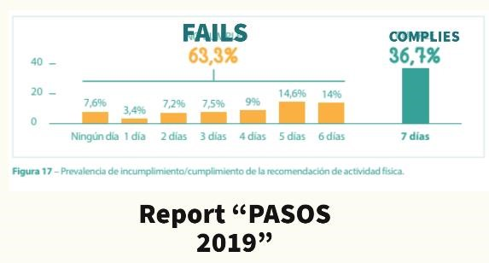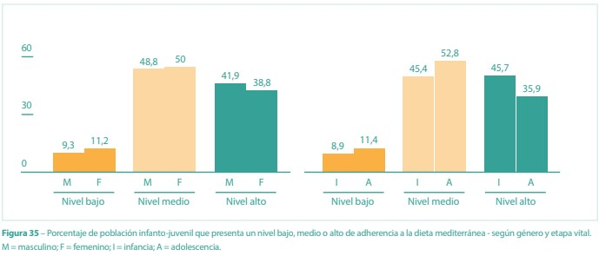

In Spain, the hours of physical education in schools are between 2 and 3 hours per week, which is very poor for young people who no longer take part in sports activities outside school hours, so one of the aspects to be corrected is to increase the hours of physical activity in schools and the promotion of extracurricular sports activities that allow them to continue taking part in physical activity. In this case, only 36.7% of the child population complies with the WHO recommendation of 60 minutes of daily physical activity. (STEPS - GASOL FOUNDATION)

-

COMPLIANCE
-

NON
-
COMPLIANCE OF RECOMMENDED PHYSICAL ACTIVITY

A major factor in this increase in obesity is also poor diet. Moving away from a healthy diet leads to an
increase in calorie consumption which, together with a lack of physical activity, determines the appearance
of obesity. The traditional Mediterranea
n diet has gradually moved away from the home and higher calorie
foods have appeared in the diet.

MEDITERRANEAN DIET ACCEPTANCE

- Brief analysis and reflection on the issue and risk of technological isolation of young people, due to the excessive use of digital tools and applications.
SPAIN
If we analyze the consequences of obesity in the short, medium or long term, we would have the following problems in each of the stages:

Short-term consequences
- Increase in cardiovascular risk factors
- Increased incidence of type 2 diabetes
- Sleep disorders due to breathing difficulties
- Increased social isolation due to difficulties in physical activities or games.

Medium-term consequences
- Increased medical complications for those who have been obese since childhood.
- Increased problems in relationships with others in a complicated stage such as adolescence.

Long-term consequences
-At a medical level there is an increased risk of diabetes, cardiovascular diseases, certain types of cancer.
- Social isolation
- Difficulties in the sustainability of health systems.
- Lower labor productivity

Getting our young people to see the problem and be able to take action to change their mentality is the great challenge of "MOVE". To create dynamics in their family and social environment that encourage an active life and healthy eating as a start to defeat sedentary life.
To this end, sports activities play a fundamental role because they are the quickest way to get started in sport. We must never tire of promoting our sport and instilling in young people the benefits of physical activity.

“Report Pasos”, 2019, Gasol Foundation

4.5. Cyprus
Municipality of Pegeia (CYPRUS) wasn’t present at the Peer Transnational Meeting (M2).

5. The Peer Transnational Meeting (M2)
Due to the 2019 SARS-cov-2 pandemic, partners gathered on the Microsoft Teams online platform on November 26 and 27 2021. Below the daily programme:
DAY 1 (afternoon)
Welcoming Session  15:00 – 15:30 | - Registration and welcome (15 min)  - MOVE coordinator address on the state of the project (15 min)
The role of sport to foster social inclusion and respect: drawing from partners experiences 15:30 – 17:00 | - Ambition of the “MOVE” toolkit (5 min)  - Participant presentations: country-based analysis (15 min each)  - Discussion and conclusion (10 min)
Towards the “MOVE” toolkit: starting session  17:00 – 18:30 | - Ambition of the “MOVE” toolkit (5 min)  - Participant presentations: country-based analysis (15 min each)  - Discussion and conclusion (10 min)

DAY 2 (morning + afternoon)
Building the “MOVE toolkit”: observation and analysis 10:30 – 13:00 | Team working on 1) the negative effects of excessive sedentary lifestyle, and 2) the risk of technological isolation of young people
Building the “MOVE toolkit”: designing sport-based effective actions  15:30 – 17:30 | - Team working on the design of sport and educational activities to address the risk of childhood obesity or technological isolation  - Team working on the design of sport and educational activities to foster social inclusion and respect  - Designing methods and tools to measure children, adolescents, and youngsters’ satisfaction in the participation to the local labs and sport events
Sharing the “MOVE toolkit” 18:00 – 18:30 | - MOVE coordinator presentation of the toolkit with the support of the two team representatives (15 min)  - Discussion and conclusion (15 min)

6. Activities proposed to stimulate the reflection of young people on the focus
themes of MOVE Project
During the comparison between the partners at the Peer Transnational Meeting (M2) the models that have emerged to stimulate the reflection of young people are:
- SPAIN
Title | “Move with handball”
Duration | 120 minutes
Space | Sport center and adjoining rooms
Technical requirements (necessary materials) | handball balls, benches, hoops, hurdles for physical activities sheets of paper, pencils for group dynamics
Number of participants | 60
Methods and techniques | Presentation of the workshops, warm-up, kilocaloric circuit, minihandball games and group dynamics to address the problems of sedentary lifestyles.
Aim of the activities, game,  (Expected learning outcomes) | - Know a sport close to their environment that allows them to be physically active.  - Conduct group dynamics to analyze the consequences of sedentary lifestyles and their relationship with obesity.  - Reducing risk factors in childhood (children who are more physically active and at a healthier weight) at ages when, for example, coronary heart disease has been shown to begin to develop.  - Appreciate and understand the positive values of physical activity in daily life on a physical, social and mental level.  - To provide basic information on nutrition and physical activity for schoolchildren in general and for overweight and obese children in particular in general and for obese and overweight children in particular.
The session step by step | Duration | Description
(With timing and responsibilities)  Description of each activity, how to play, | 120 minutes | We will work with 3 different groups of school children. Upon arrival at the center, the general objectives of the activity will be explained to them and they will be divided into groups to develop each of the tasks.  Activity 1: Distribution of groups, explanation of the activity and warm up (20 minutes). Activity 2: Mini handball matches where schoolchildren will learn about our sport, the basic  rules and the game spaces adapted to schoolchildren.  Teams will be formed to learn the different skills necessary to play handball as well as the values that are worked on: companionship, effort, respect Activity 3: Kilocaloric circuit. From the work done in collaboration with the teachers of the institute, the students know the calories of the food and we create a circuit where they can burn everything they eat. They will do agility, coordination, strength and aiming tests.  Activity 4: Group dynamics. We will divide the area into 3 working groups. In the first part you will be given information about obesity, the reasons for it and possible solutions. In the second part, each group will have to create a story with characters based on the information given, where problems and solutions to the issue will be raised.
REPORT  (Synthesis of emerging key issues, most important outputs, results of the session – that will be included in the report) | Getting schoolchildren to see the problem of sedentary lifestyles, which they can avoid through physical activity.  Information on eating habits and food intake.  Respect for children with obesity problems.  With the activities we aim to transfer the information and routines to the family environment.  We will analyze how many children sign up for physical activities after the workshops.
Source of information | "Guide for educators. Play, eat and have fun with Tranqui."  Alicia Mª Alonso Martínez, Cecilia Gómez Vides y Javier Ibáñez Santos  Gobierno de Navarra

- LITHUANIA
Title | Lithuanian model
Duration | 30 minutes (can be devided into 3-6 sessions)
Space | Sport hall or Open area
Technical requirements (necessary materials) | Depending on the availability. It can be basketball / football / volleyball / handball , etc area. Pen, paper, box, scarfs.
Number of participants | 10 - 16
Methods and techniques | Warm-up activity, practice activity, debriefing
Aim of the activities, game,  (expected learning outcomes) | Usually and almost unconsciously children and youngsters exclude from the sport and physical activities/games those, whom they consider as “not useful” in the field (higher weight, too small or too tall, not able to run fast , has some disability, exclusion can be based on gender or culture, etc). It is obvious, that in team sport every player wants to score and be the “number one”. Those with fewer abilities and opportunities are pushed away and are just staying in the field even if invited to be the part of the team. As a result, those “weaker” children and young people loose the last interest in sport and physical activity, choose digital tools and condemn themselves to technological isolation and excessive food consumption.  The aim of the activity is to set different rules to the players and let participants to “step into others’ shoes”. This way few goals can be achieved:  - Social exclusion in sport and physical activity will be prevented.  - Active participation in sport and physical activities/games will be promoted.  - The attractiveness of the sport and physical activity will be rediscovered / increased.  - Element of the fun will be included
The session step by step  (with timing and responsibilities)  Decription of each activities, how to play, | Duration | Description
 | 1 each activity can take aprox 5 mins | Activity 1: Warm up. Depending on the type of the sport chosen as the basis of the activity (basketball/ football/ volleyball, handball). This example will be provided on the basketball basis.  Activity 2: participanst are divided in 2 teams. According to the number of players in each team, coach writes on the peace of paper the role each player will have to perform: eg. „can‘t score“, „plays with left hand“, always passes ball to others“, „always stops when gets the ball“, „closes eyes while scoring“, „moves 3 steps after getting ball and passes“, etc.  Pieces of paper with roles go to the box and each player randomly picks paper with his own role and do not show his role to other participants. Each player performs its own role.  Activity 3: Roles can be switched and game session repeated.  Activity 4: Participants are divided into pair. One player puts scarf on his eyes and becomes „blind“. The other players helps him to get ball and provides commands where to move to get closer to the basket: „right, left, forward, etc“. When the „blind“ player reaches the appropriate place for scoring, the assistant commands „score“ and the „blind“ player tries to score.  Modification: Players can be divided in pairs and in teams (eg. 3 pairs in each team). The assistants take the hand of the „blind“ player and leads him across the playing field. The assistant can catch the ball, move with him, but he can‘t score. Only „blind“ participants can score.  Roles in pairs can be changed and the game repeated.  Modification: wights can be put on the hands, legs and waist of the participants. This would be simulation of the “obesity”. Other rules can remain the same.  Activity 4: debriefing. How have you felt performing the given role? Did you like the feeling experienced during the game while performing the certain role? Why have you felt the way you did? How have you felt being “blind”/”obesed”? etc.
REPORT  (Synthesis of emerging key issues, most important outputs, results of the session – that will be included in the report) | - Social exclusion in sport and physical activity will be prevented.  - Active participation in sport and physical activities/games will be promoted.  - The attractiveness of the sport and physical activity will be rediscovered / increased.  - Element of the fun will be included.  The payers will understand that the active participation in sport and physical activity is important to everyone regardless the physical condition.  The awareness about the importance of sport and physical activity as an overweight and obesity prevention tool will be raised.  Sport and physical activity as an alternative to the games in digital devices will be promoted.

7. Activities proposed to use the language and methodologies of sport activities
as educational tool and instrument of social inclusion and respect for different
people
During the comparison between the partners at the Peer Transnational Meeting (M2) the models that have emerged for activities proposed to use the language and methodologies of sport activities as educational tool and instrument of social inclusion and respect for different people are:
- ITALY

Title | Postural activity and circuit training
Duration | 45 minutes
Space | Sport hall or Open area
Technical requirements (necessary materials) | Depending on the availability. Dumbbells, barbells, kettleball
Number of participants | 20
Methods and techniques | Warm-up activity, practice activity, Stretching
Aim of the activities, game,  (expected learning outcomes) | The purpose of circuit training is to reduce fat mass, increase lean mass and, with postural activity, prevent pain in the spine. Some of these exercises will be offered to children with the playful method
For boys and adults there is a warm-up session (with dynamic stretching on the postural muscles), a subsequent circuit phase and a final phase of static stretching.  For children, the circuses training will be replaced with games of different sports activities. | Duration | Description
 | - warm-up: 10' (2 series of 10 repetitions per exercise);  - circuit training/training for children: 25' (3 series of 15 repetitions);  - Static stretching: 10' (2 series of 10" per exercise) | Activity 1: The adult warm-up consists of five exercises (dynamic bird dog, cat-cow, dynamic cervical stretching and two stick exercises for the scapular district), preceded by 5' of aerobic activity.  For children the warm-up takes place in the form of a game (stages in the middle of the field, passes with the ball etc...)  Activity 2: Participants will be divided into four groups for the four total-body stations for circuit training. Once a station is finished, each group will move on to the next until the fourth. There will be floor exercises (push-ups, squats...) and dumbbells (curl, front lifts...).  Children will also be divided into four groups for the four activities proposed (handball, 100 m, long jumps, obstacle course). Once a station is finished, each group will move on to the next until the fourth  Activity 3: 4-5 Static stretching exercises (bird-dog static, leg stretching etc...)
REPORT  (Synthesis of emerging key issues, most important outputs, results of the session – that will be included in the report) | For children and adults:  1. Have learned some postural exercises and fitness exercises;  2. Understanding the importance of circuit training, stretching and postural activity;  3. Make sure the activity was fun.  For the children:  1. Entertain them;  2. Promoting some lesser-known sports in Italy (in this case handball and athletics);

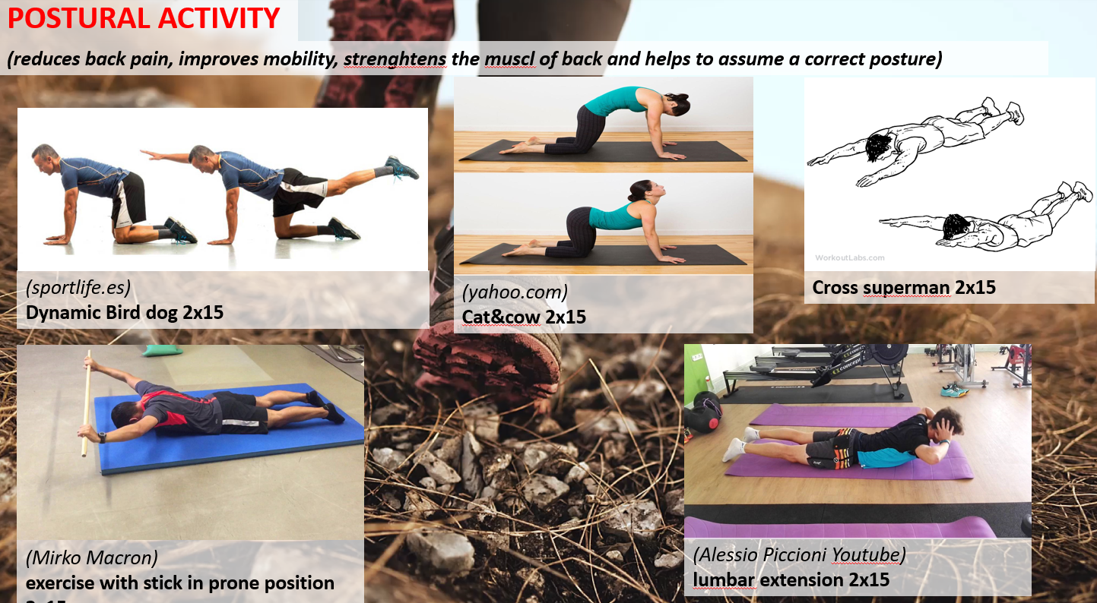

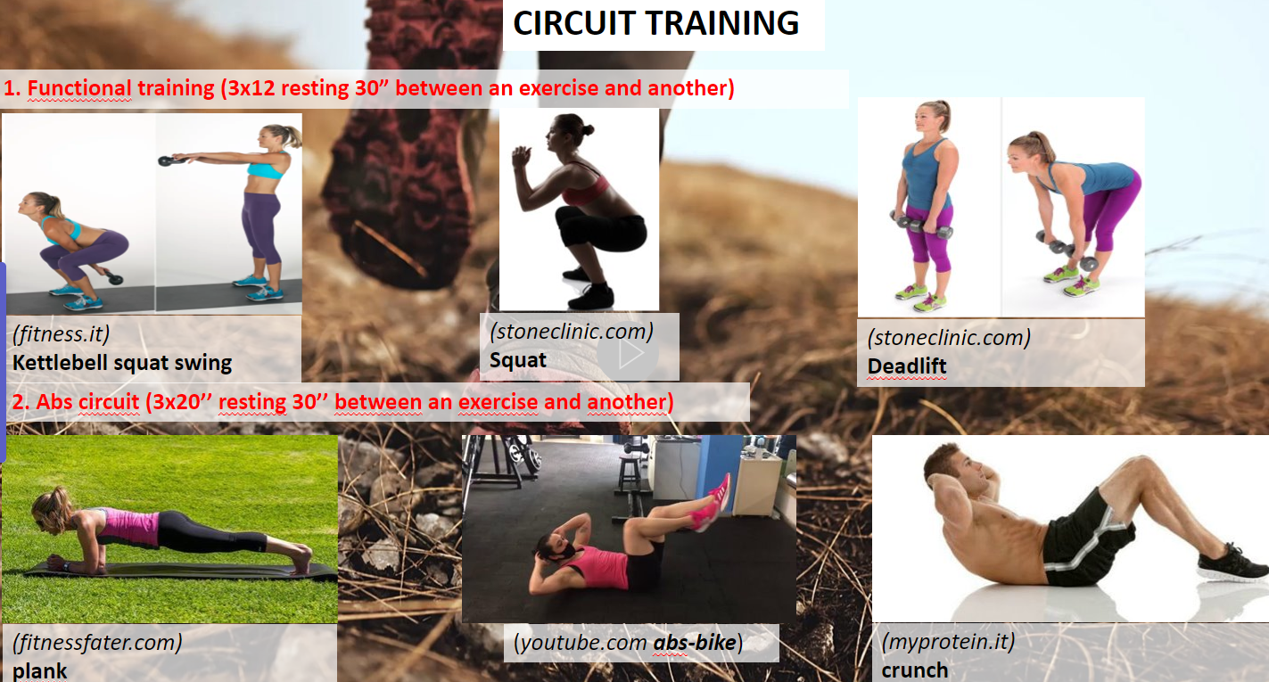
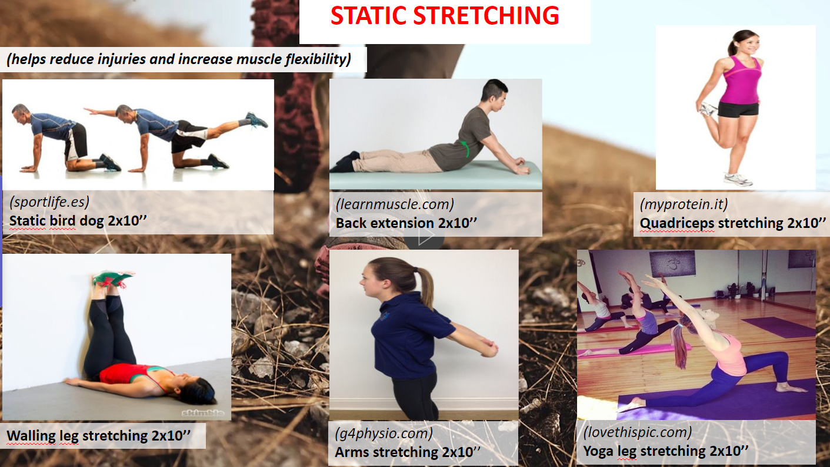
Link video Castel Games:
https://www.instagram.com/p/CSHaTZdDWDQ/?utm_medium=copy_link​
(Images extracted from the power point exposed during the day of the meeting 26-27 November)
- SPAIN
Title | Feel it yourself
Duration | • 30 minutes
Space | • Court
Technical requirements (necessarymaterials) | • 5 Boxes, scarf (for the eyes), and different materials that they use in handball activities
Number of participants | • 20, in pairs
Methods and techniques | - Presentation, they should know that they have an advantage because there are objects that they see very often and someone with visual impairment might never even have seen it, or know what it is.  - They will have to touch inside the box and try to guess what is inside  - Rest of the children could give instructions to the players
Aim of the activities, game,  (expectedlearningoutcomes) | - Children have to guess what is inside the box. We use differents thing that thay use during the training  - They develop their senses  - They put themselves in the shoes of children who are visually impaired  - Be able to understand the difficulties that children with visual problems go through every day
The session step by step  (with timing and responsibilities)  Description of each activities, how to play, | Duration | Description
 | 10 minutes | Activity 1: explain the limitations of visually impaired children and do some basic activities such as walking.  Activity 2: go to the boxes in order to try to guess what is inside. Will be very common objects and very easy to know what is that. For example, a ball. Activity 3: they try to use the objects with the blindfolded (bounce the ball)  Activity 4: Share the experience in group. Children have to explain the feeling during the activity with all the troubles
REPORT  (Synthesis of emerging key issues, most important outputs, results of the session – that will be included in the report) | information about visual problems in children respect and understand them
Source of information | https://juegosinclusivos.sanitas.es/  Guide to good practice in education including. Save the children

Title | “Sport day”
Duration | 120 minutes
Space | streets of the village and sport center
Technical requirements (necessary materials) | balls, goals, psychomotricity equipment, bouncy castles
Number of participants | 120
Methods and techniques | Warm-up activity, practice activity, presentation
Aim of the activities, game, (expected learning outcomes) | - Meet children involved in other sports activities.  - Make mixed teams of different ages for each activity, encouraging teamwork.  - Respect the abilities of each person in the different workshops.
The session step by step  (with timing and responsibilities)  Description of each activity, how to play, | Duration | Description
 | 30 minutes Each activity | Activity 1: FOOTBALL. Make several teams with boys and girls and play matches. The playing field is a bouncy castle.  Activity 2: HANDBALL. Make several teams with boys and girls and play matches. The playing field is a bouncy castle.  Activity 3: CYCLING. To carry out a circuit individually or in teams in which they have to overcome different tests in order to continue advancing  Activity 4: PSYCHOMOTRICITY. Aimed at the youngest children and their families. They have to do skill and coordination circuits with different materials adapted to their age.
REPORT  (Synthesis of emerging key issues, most important outputs, results of the session – that will be included in the report) | To make the municipality's sporting activities visible.  To create friendships between the different sports activities.  To get parents involved in their children's sporting activities.  Give special importance in each workshop to teamwork, helping those who are less skilled in sports.  To instill respect for everyone's abilities and to work on integration within the team so that they feel better.

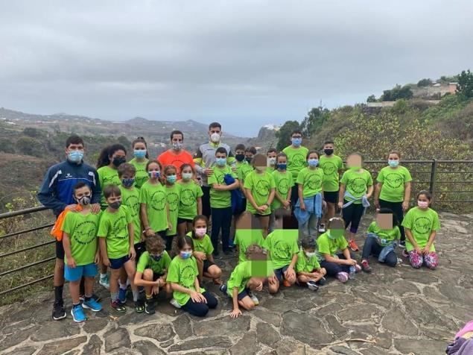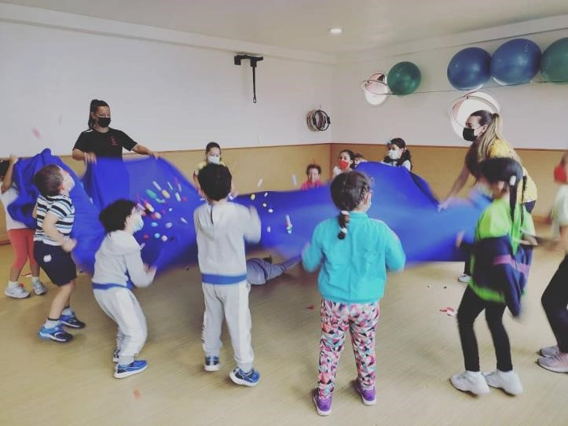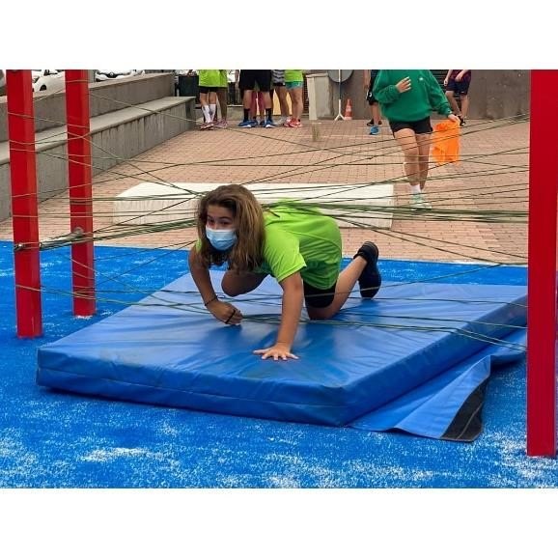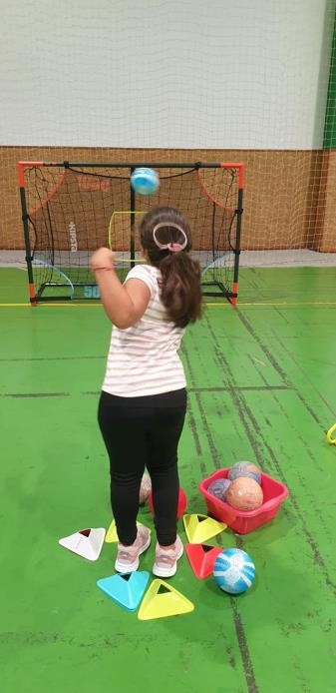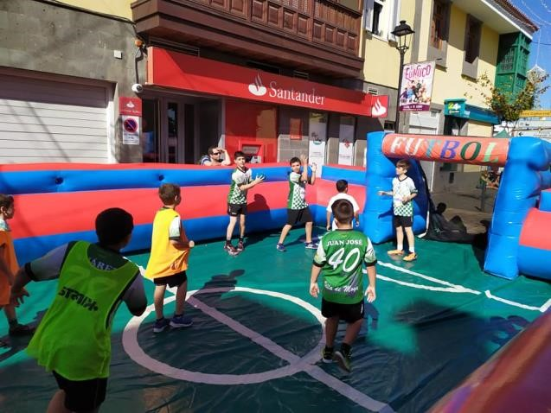

GREECE
Title | Aqua gym - Circuit training
Duration | 40 minutes
Space | Swimming pool
Technical requirements (necessary materials) | none
Number of participants | 15-20
Methods and techniques | Warm up-activity, practice activity, Warm down activity
Aim of the activities, game,  (expected learning outcomes) | Circuit training, cardiovascular improvement
The session step by step  (with timing and  responsibilities)  Decription of each activities,  how to play | Duration | Description
 | - 5min;  - 30 min (2 circles for eache);  - 5 min | Activity 1: High knees, Heels back, Frog jumps  Activity 2: Arm exercises: push on the front/running, push down/running, roll forward/ frog jumping, roll backward/frog jumping  Trunk/legs: Stepover front/eggbeater kick, stepover back/eggbeater kick, trunk rotation/ cross kick, trunk rotation/front kick, side abdominals  Activity 3: Easy running, floating arms, stretching
REPORT  (Synthesis of emerging key issues, most important outputs, results of the session – that will be included in the report) | Improving of cardiovascular ability, strengthening of the muscles
Source of information  Videos link  Book title  Project title  Etc | https://www.youtube.com/watch?v=jFltiKSNtHA

8. Activities proposed to measure the level of satisfaction of young people during
the local activities
At the end of the local labs the partners will have to verify the following requirements with a rating from 0 to 5 (from bad to excellent):
1) Are the proposed sports activities effective against the problems examined within the Project (sedentary lifestyle, obesity, etc...)?
2) Have the proposed sports activities been well received by the various age groups involved?
3) Was there enthusiasm for the various activities proposed?
4) Was there good cooperation between the project partners?

